Why Your Failures Qualify You For Success & Donald Trump
May 19, 2016

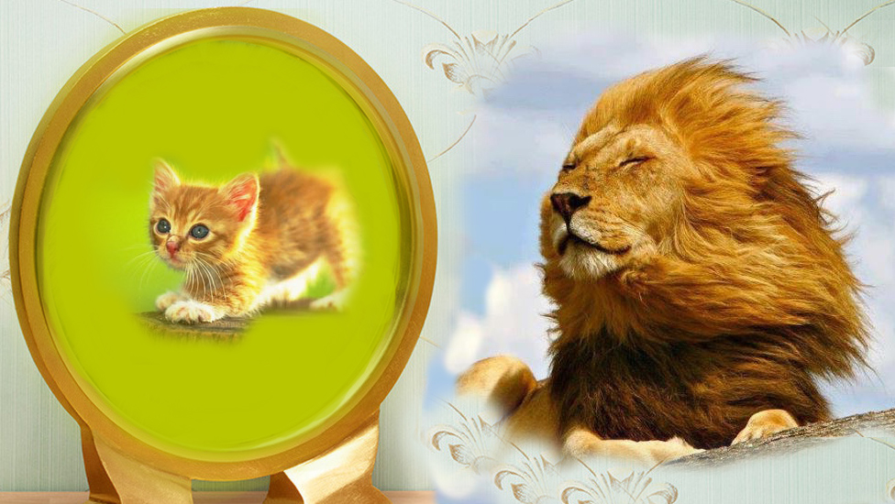
Well, precious Heartdwellers. I need to make an announcement before I get into the message. I just want you to know that we still have books and CD’s and thumb drives on Amazon and they are about to charge us an outrageous amount of money for storage if they don’t get sold.

Sooo...I'm telling you ahead of time that we have paid all the costs for making these out of our own pockets, so you could afford them. And I just want to remind you that all you're paying for on Amazon is the processing fee that they charge and the shipping. Everything else for the thumb drive and the album have already been paid by ourselves or by donors. So, that's the only cost involved in getting these. Otherwise, they'd start around $25, they'd be very expensive, but I think they're priced at like, $6. So, get them while you can and you can have them when things get bad. It will be too late at that time to get anything.

Before we pull them off Amazon, I'm just making a last announcement to you, please consider all the people that are going to be left behind that you know, and what you can do for them before it’s too late. My highest recommendations are for the Tethered Thumb Drive, and the album Tethered, which makes a very nice gift because of the packaging and it's got the essence of the important things on it. These are things you can leave behind for your relatives in a big envelope with their names on it. I also recommend you put them in those inexpensive EMP protection, Faraday Cage Mylar envelopes in case there ever is an EMP attack after the Rapture, they will be able to open them on a new device. 'Cause in an EMP attack, all information is wiped off of every drive, unless it's in what they call a Faraday cage.

It is our responsibility to touch every single soul we can so they will understand they are not doomed, God does care about them. So many will commit suicide because their entire sense of self worth revolves around what they own and financial security. So many will ask where is God? Why didn’t He tell us this was going to happen? Others will say, there is no God, or He wouldn’t have let this happen. On the thumb drives we explain why He allows these things. And that may very well be the point in their lives where they realize GOD IS REAL. And God IS in control.

This indeed is what it’s all about: God is real and there is HOPE, so that people would have hope when nothing makes sense. So please, if you can order a few more of these resources. And one thing to remember: the cd’s and drives are manufactured to last, not like something you make at home where the files can deteriorate after time. I’ve had that really sad experience where I was backing things up on CD and I went to pull them up and they were all gone. There was just a black icon … nothing left but that shadow.

Now for the message.

The Lord Jesus is with us, Heartdwellers. He broods over us like a mother hen over her chicks, and has so much wisdom to impart to us. And as always, I am the guinea pig…

I’ve been preparing for the painting He has commissioned me to do…preparing by researching my materials and getting an idea of how to go about this.
I, I, I.

Well, most of you know where the “I” doing it leads to. That’s right, failure and confusion. So, here I am to confess my failure and confusion and complete frustration about how to go about this. He did tell me it was wisdom to research my materials before I got started, but I never came to Him and asked Him directly, 'How do You want me to do it?' So, He left an open door there for me to be foolish - and I walked right through it!

"I bring my confusion to You, Lord. I don’t want to waste anymore time on this."

He answered me, "I understand, and I’m here to clear it up for you. Why did it take you so long for you to come to Me?"

I didn’t think of asking You, I just assumed.

"Well, you are showing much more wisdom now. Thank you for coming to Me. You already know what I want you to use, right?"

Here He is referring to the vision He gave me during worship that solved my dilemma about which medium to use. I had already invested in another medium which can be converted with a little work, but I felt badly that I might have wasted money.

"I do not want to shame you. I see you are truly sorry and afraid to buy anything at this point. You are familiar with this medium, and you can work your pastels into it. This can be done, quite easily I might add. You can have a peace about this, Clare, this is Me. Work with what you have a few other things, and we'll be able to do this together. I will not let you down. I know how frustrated and disappointed you are. Let Me help you, we CAN turn this around.”

He continued, "You are in a good place now. A really good place. Contrition is always the very best place to be. Oh, if only My children could stay in this place, how humble they would be. Contrition and humility go hand in hand.

"Beloved family of God, all of you will benefit by deep contrition for your sins. Contrition moves the jagged rocks from the site where the foundation of humility is poured. When you encounter yourself in failure, it is one of the greatest gifts I can give you. You become aware of your nothingness and My great mercy and love for you.

"When you begin to see yourself as you truly are, I pour My love and grace all over you until you are nothing but a tiny speck carrying a huge bundle of light. Like an ant with a big twig, you aren’t even seen anymore. You are hidden beneath the gift of grace that dominates you.

"Contrition is the pre-eminent gift of predilection…meaning that you have been chosen and responded appropriately. Many are called, few are chosen, and even fewer respond. When you empty yourselves and become so small and insignificant in your own eye, even to the point of being a ‘detriment’ to yourself and others, then you are in the position to be used by Me for My highest callings.

"To get to this place, you will stumble many times. Indeed to stay in this place, it is necessary for you to continue to stumble, but getting right back up with My hand lifting you from that pit. I allow this because more than any other attribute but Love, Humility is necessary for all the gifts to flow and for you to be raised to that station in life destined for you from birth.

Although I am God, I did not consider equality with God in the eyes of onlookers something to cling to, but I emptied Myself, taking the form of a servant, even obedient unto death on an infamous cross…(He's referencing Philippians 4:6 there.)

"I could be trusted with the most precious gifts because My Heart was not Proud. I assumed not only the body but the helplessness of man in his earthly condition. I did this for you, Beloved Church. I did this to reveal how you, too, must have this heart, being the lowliest of low in My house.

"Yet so many fight to be superior. To have more knowledge, more power, more, more, more of everything to secure their position. Do you know that is the trap of tyranny? Yes, when you are the best and have the most, you have to fight to maintain that status. You lose sight of who you truly are, why you are here and who I made you to be. Your standard becomes the same as society’s and you lose your identity as the precious person I made you to be. In this place, you are continually fighting to maintain your status and your life becomes a war zone for you - not the beautiful expression of your work through Me, with Me, and for Me, so that I shine through you.

"I am telling you this, My dear ones, because I don’t want you to be afraid of encountering your real self. It is quite necessary to you before you can be trusted with My gifts. Don’t be afraid to be feeling like a lion and catch a glimpse of yourself in the mirror and see that you are but a little kitten. There is nothing shameful in being little. Little is beautiful. All who have become great in Heaven, on Earth were very, very little ones.

"Moses did mighty things, yet in his own eyes he was so little and abased that he feared to speak for himself. The breaking he went through when he left Pharaoh's house, the forty years he tended sheep, totally unknown out in the wilderness - all of that prepared him to encounter Me in the burning bush and remain very little in his own eyes, so he could carry the anointing and set My people free.

"The fastest way to accomplish great things is acting from total sincerity of the heart. Collapse before Me saying, 'Lord, I am too little, I can’t do this, I just can’t do it.' Then relying on Me to execute whatever it is. I come rushing to the aid of a little one such as this. Yes, you are a little one when you have embraced that place with your whole heart.

"And in contrast to this, the quickest way to fail at anything is to do it yourself. Even if you succeed in the eyes of others, you fail before Me and the great cloud, because it was done with the wrong heart attitude. But it is then that I allow the enemy to sift you with the next undertaking and the next and the next until the self-reliance is completely gone out of your character.

"How opposite to the world is that??? Instead of proving your competency over and over again, and thus qualifying for My work, you must fail over and over and over again in order to sign off on the application. I will not take anyone into My service who has not been humbled by multiple failures in the past.

"The man who has failed knows his limitations. The man who has failed looks on others as better than himself. The man who has failed has charity and compassion on those who struggle as he does. The man who has failed comes to Me on his knees and hands it over to Me saying, 'I can’t do this Lord, I tried, but I can’t serve you as I should. I have failed.'

"This is the one I embrace and lift to his feet and say, 'Come let us reason and work together. I will do it through you. Now that you have learned the truth about yourself, I can bring success to the work of your hands.'

"Every great vessel that has ever served Me has a profound understanding of his absolute nothingness. Without this attitude, I never could have used him. He might look confident to you, but I see him on his knees confessing his weaknesses. I see what you do not see. In his heart, he is but a kitten, while to others he may appear as a lion."

Lord, why am I thinking of Donald Trump here? Is he one such man?

"No, Clare, not yet - but he will be. I am calling him into My service and he will learn that something beyond him is responsible for his successes. He will learn that I gave him all that he has, I led him and guided him with wisdom. He will recognize that nothing he has done has been done on his own.

"This is the other way I work with souls for My purposes. Look at Nebuchadnezzar. He was a mighty ruler, but one day he woke up crawling on the ground and snorting like a pig, totally unaware of who he once was. That is how I got his attention. Pray that I don’t need to use such drastic means on this candidate. He will encounter himself stripped of everything, standing before Me in My mirror. Then he will see who I truly am and who he truly is - and is not. Then the beauty of the man will arise, with Me living through him.

"Oh, you all have so much to learn about human nature and what I can accomplish with even the vainest of men. Is it not written that I hold the king’s heart in My hands?"

And that Scripture was quickened to me, so I looked it up. The king's heart is like channels of water in the hand of the LORD; He turns it wherever He wishes. Every man's way is right in his own eyes, But the LORD weighs the hearts.…Proverbs 21:1-2

The Lord continued, "Do you see, My Christian people? You are looking at this man and wagging your fingers because you do not know the Scriptures, nor My power to turn hearts. You are making decisions based on your own limited wisdom and presuming you know what is best. You will presume yourself into another Obama and the New World Order if you do not put your trust in Me.

"This is why I tell you continually, opinion is no substitute for discernment. When you discern My times, My seasons, My choices, you will go against the current being generated by the ruling elite. When you think for yourselves, basing everything on your personal preference and the opinions of others, you will find yourself endorsing evil. Discernment takes time. Opinion is the lazy man’s way. This nation is in this fix right now because you were lazy. Don’t make the same mistake. Discern My times, My seasons and My choices. Stand with Me, not with popular opinion.

"Yet, I do not want you to lose the gist of this teaching. Beloved, this is about failures leading to the greatest success and seeing yourself in My mirror as the little kitten in need of protection and help. When you finally see yourself this way, that is when the lion will rise up to do it all through you.

"May you be confident in My Love. So confident that you allow yourself to see clearly in My Mirror who you are and who you are not. May you trust no longer in your own devices, but come to Me on your knees. 'Lord, I am too little, I cannot do this.' In your hearing ears, I offer you these graces. Take them, cherish them, and become who I have always created you to be."

